SUMMERVILLE CREDIT UNION · CONSOLIDATED MEMBER GUIDE · CSUM-01 of 30
Login & Authentication

Module: nFinia Digital Banking > Login
Sources: Summerville Reports Series A (36 docs) + Series B (25 docs) | Features: nFinia Documentation Features Spreadsheet
01 PRODUCT SUMMARY

The Login & Authentication module is the security gateway to the Summerville Credit Union digital banking platform. Every member session begins here — it is the single point of identity verification before any account data, transaction capability, or self-service function is accessible. The authentication flow employs a multi-layer design: the member supplies a registered username and password, then completes a one-time passcode (OTP) challenge delivered to a pre-registered email or mobile number.
Beyond standard username/password entry, the module supports forgotten credentials recovery (Forgot User ID, Forgot Password), account unlock for locked-out members, biometric login (Touch ID / Face ID) on supported devices, and a 'Save User ID' convenience feature. A 'Sneak Peek' option on supported configurations allows members to preview their account balances before completing full authentication.
Multi-factor authentication (MFA) settings — including managing OTP delivery methods — are handled in Settings after login, but the authentication framework established at login governs all session security.

At a Glance

Attribute | Detail
Module | nFinia Digital Banking > Login
MFA Method | Username + Password + OTP (email or SMS)
Recovery Options | Forgot User ID, Forgot Password, Unlock Account
Biometric | Touch ID / Face ID on supported devices
Session Security | Tokens expire on inactivity; trusted device option available
Related Reports | CSUM-02 (Dashboard), CSUM-26 (Password & User ID), CSUM-28 (Device Management)

02 KEY USE CASES

Use Case | Who Uses It | What They Do | Business Value
First-Time Login | New enrolled member | Enter User ID and password; complete OTP challenge | Establishes authenticated session to access all digital services
Biometric Login | Returning member on trusted device | Enable Touch ID / Face ID during initial login session | Eliminates manual credential entry on subsequent sessions
Forgot Password | Member who cannot remember password | Click Forgot Password, verify identity via OTP, set new password | Self-service recovery eliminates need to call CU support
Unlock Account | Member locked out after failed attempts | Use Unlock Account flow to verify identity and restore access | Immediate self-service unblock without branch intervention
Log Off | Member ending session | Click Log Off to securely terminate the session | Prevents unauthorized access if device is shared or left unattended

03 STEP-BY-STEP GUIDE

Navigation: Navigate to https://summerville.nfinia.com (or launch the mobile app). The Login screen is the first screen presented.

Step 1 — Launch the Login Screen
The Summerville Credit Union digital banking login page is displayed. A welcome modal appears over a blue background with financial service icons, showing the User ID and Password input fields along with a prominent 'SIGN IN' button.
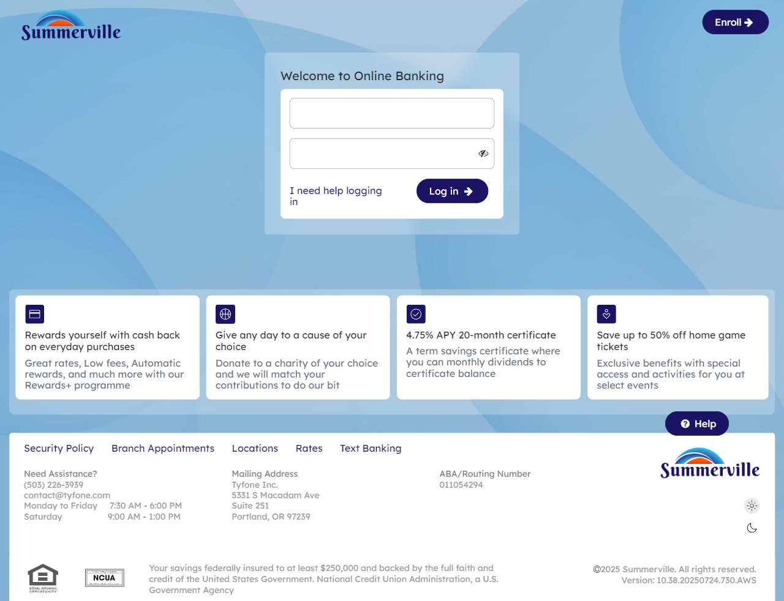
Step 1: Launch the Login Screen

Step 2 — Enter Credentials & Click Log In
The same login screen is shown. The member enters their registered User ID and password into the respective fields and clicks 'SIGN IN' to begin the authentication process.

Step 2: Enter Credentials & Click Log In

Step 3 — Select OTP Delivery Method
The Verification screen appears, offering three OTP delivery options: 'Send me a text message', 'Call me', and 'Send me an email'. The member selects their preferred method to receive the one-time passcode.
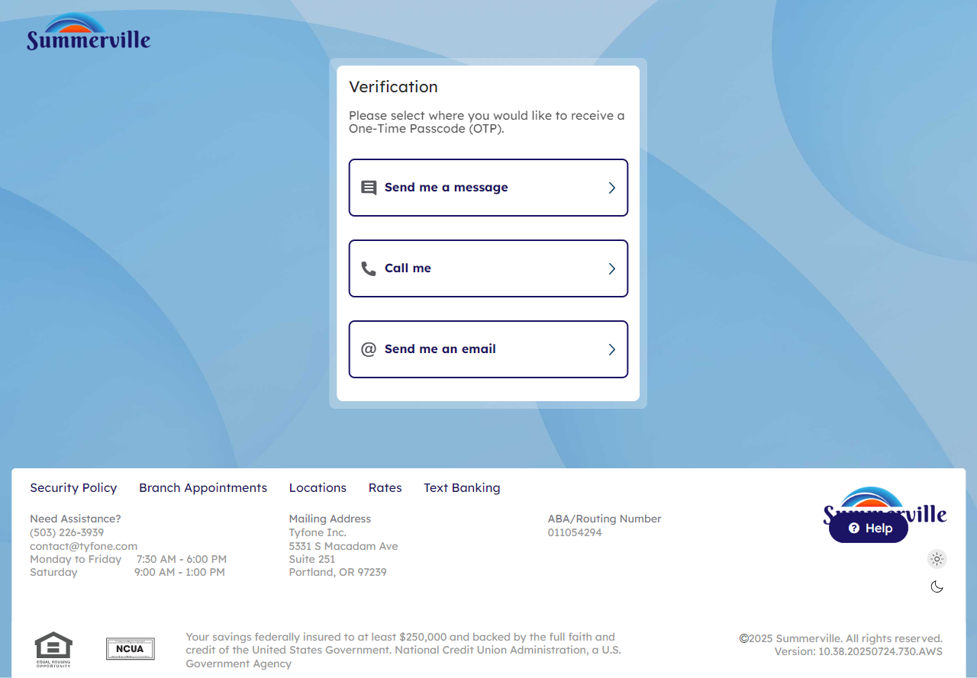
Step 3: Select OTP Delivery Method

Step 4 — Select Email Address (if Email chosen)
The email OTP option is selected. The screen displays 'Send me an email' as the chosen method with an input field for the member to confirm or select the registered email address for receiving the verification code.
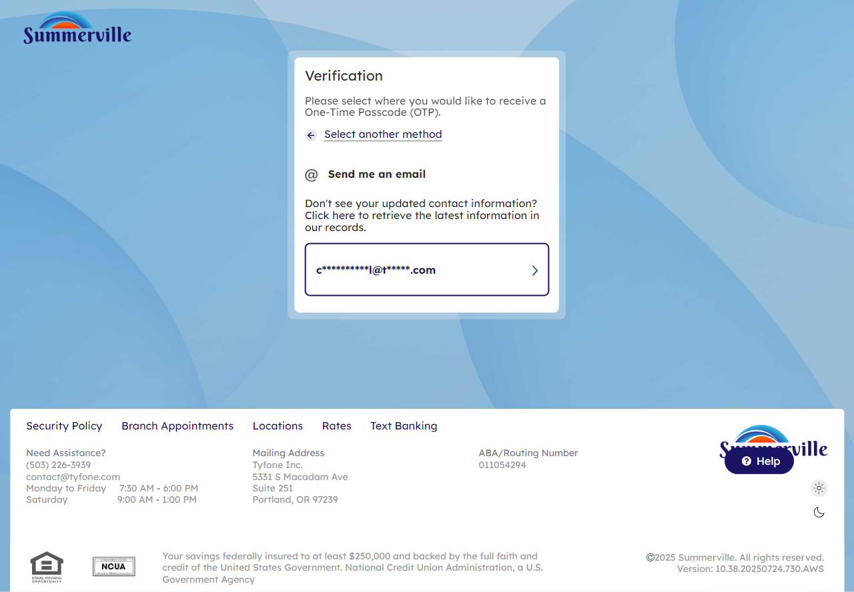
Step 4: Select Email Address (if Email chosen)

Step 5 — Enter OTP Code
A verification code entry form is displayed with an 'Enter code' text field. A 'Didn't receive your code? Resend' link is available below the input for members who need the OTP re-sent.
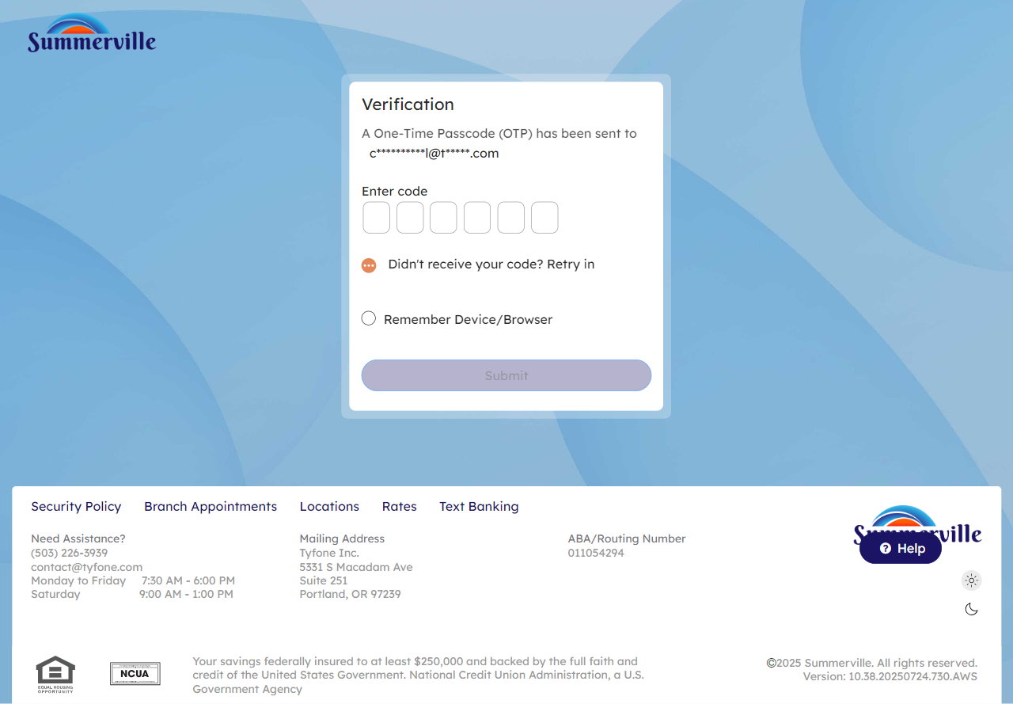
Step 5: Enter OTP Code

Step 6 — Arrive at Dashboard
The Dashboard loads successfully after authentication. The screen greets the member by name ('Good Evening, SAM WILSON') and displays account balances, a quick transfer widget, and promotional messaging.
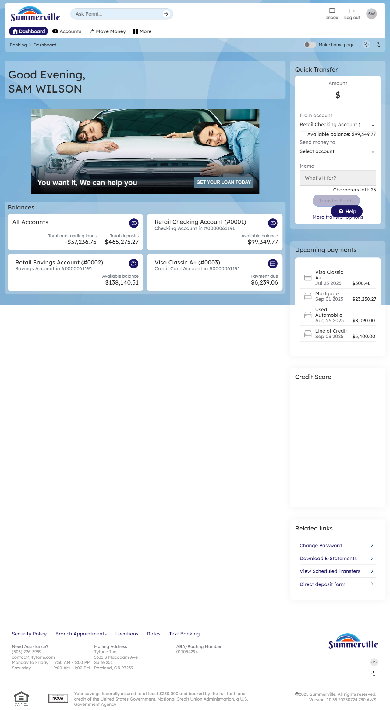
Step 6: Arrive at Dashboard

Step 7 — Access Self-Service Recovery Options
The self-service recovery page is displayed with three options: 'I forgot My user ID', 'I forgot My Password', and 'Unlock My user ID'. Each option has an icon and a 'Back to login' link at the bottom to return to the main login screen.
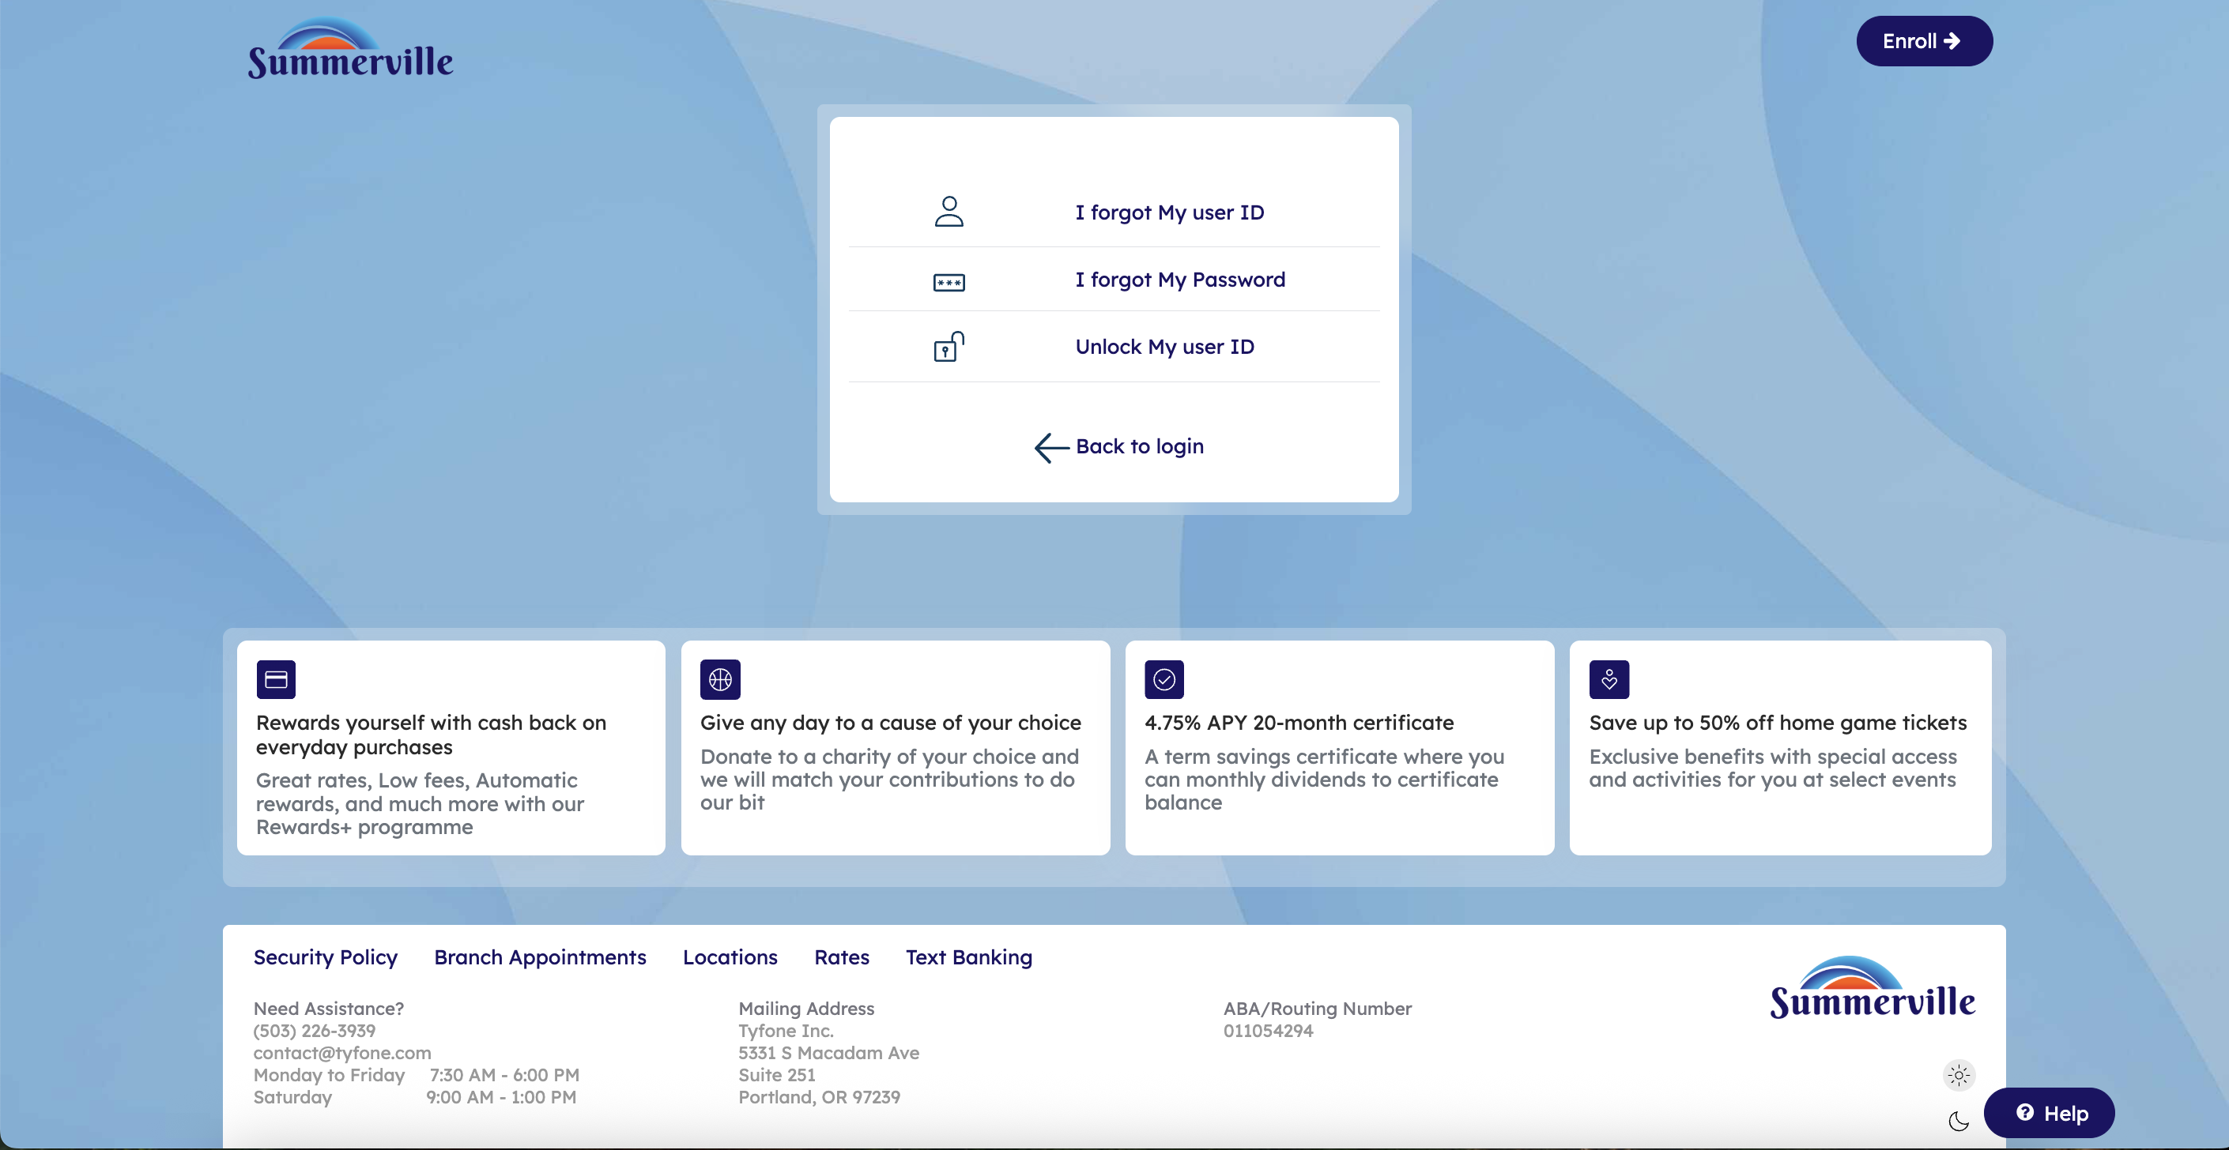
Step 7: Access Self-Service Recovery Options

Step 8 — Forgot User ID — Enter SSN & Date of Birth
The Forgot User ID form is displayed. The member is prompted to enter their Social Security Number (SSN) in two matching fields for confirmation, and their Date of Birth. A note states the User ID will be sent to the registered email and/or mobile number. Cancel and Retrieve User ID buttons are at the bottom.
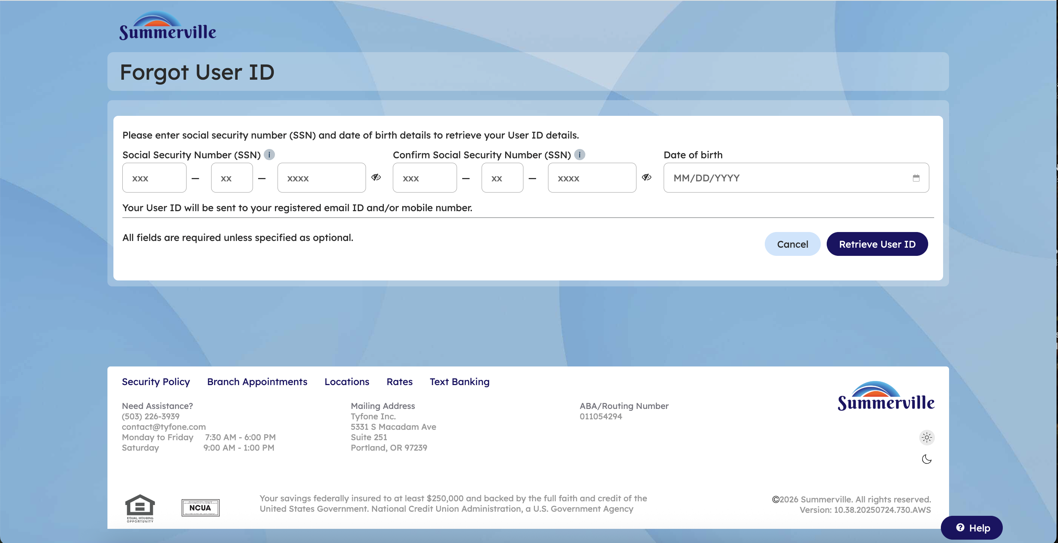
Step 8: Forgot User ID — Enter SSN & Date of Birth

Step 9 — Forgot Password — Enter Membership & User ID
The Forgot Password flow begins at Step 1 (User info) of a 5-step wizard: User info, Identity verification, Authentication, Password reset, and Success. The member enters their Membership Number and User ID, then clicks Next to proceed. Cancel is also available.
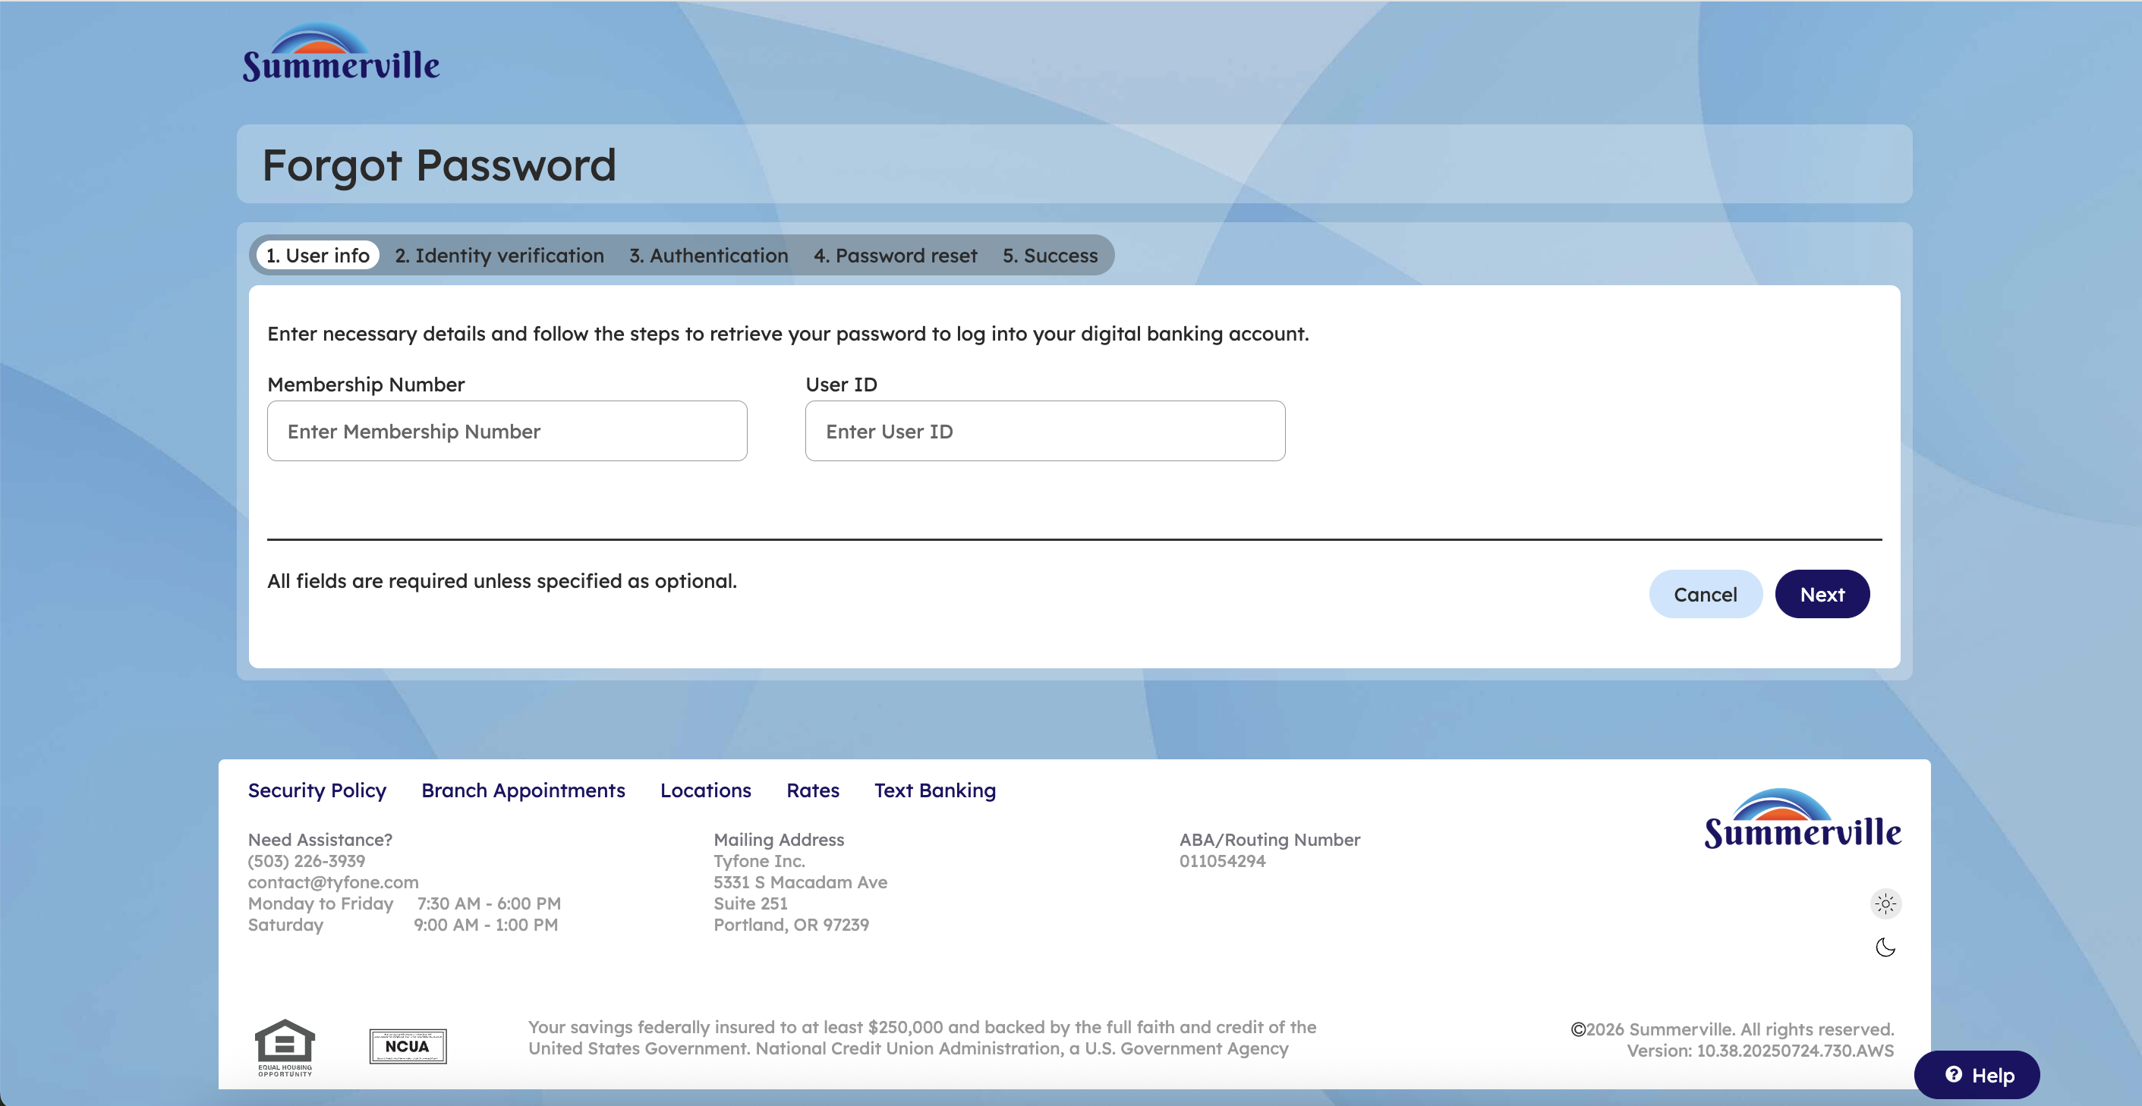
Step 9: Forgot Password — Enter Membership & User ID

Step 10 — Unlock Account — Enter User ID & Membership
The Unlock Account flow begins at Step 1 (Member verification) of a 5-step wizard: Member verification, Identity verification, One-Time Passcode (OTP), Choose password, and Success. The member enters their User ID and Membership Number, then clicks Next. Cancel is also available.
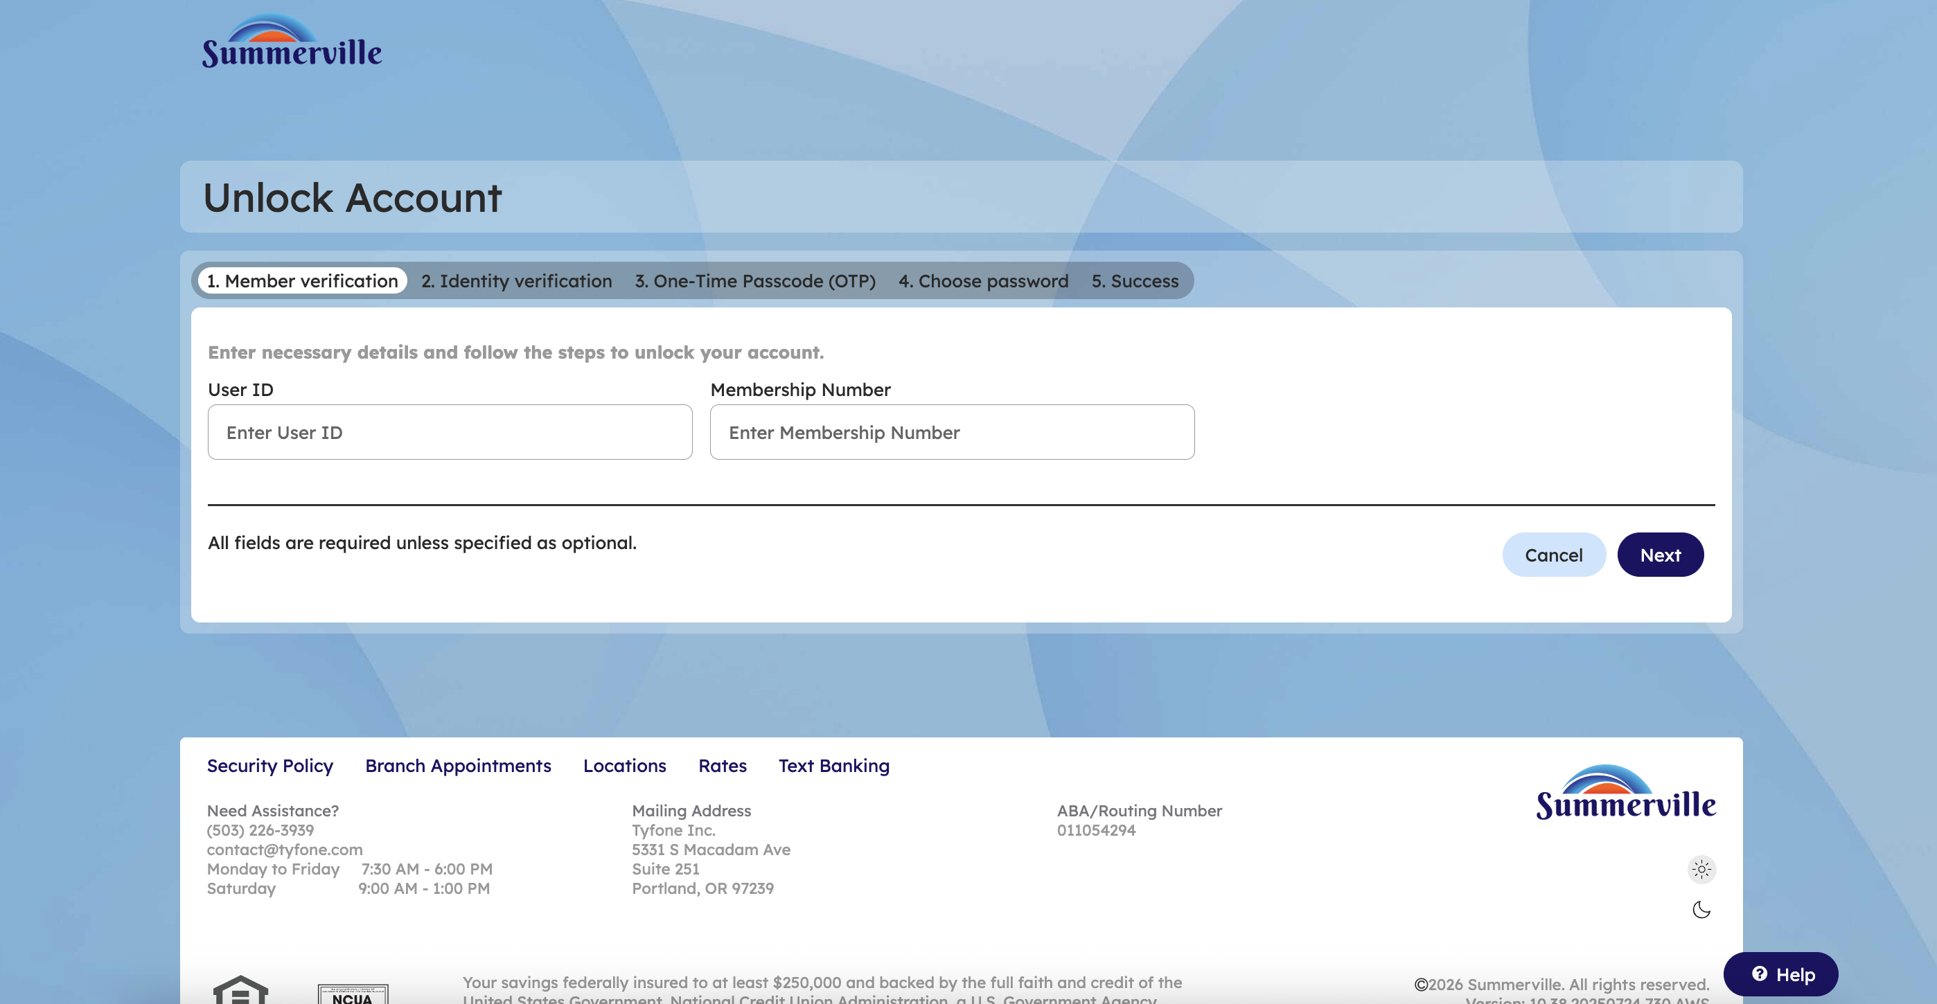
Step 10: Unlock Account — Enter User ID & Membership

